Student Name: Siqi Li

GitHub Repo Under NEU Organization:

<https://github.ccs.neu.edu/lisiqi/CS6650-DSBS-Repo>

Explanation About Client Structure and How it works:

Total Five Maven Projects as shown below:

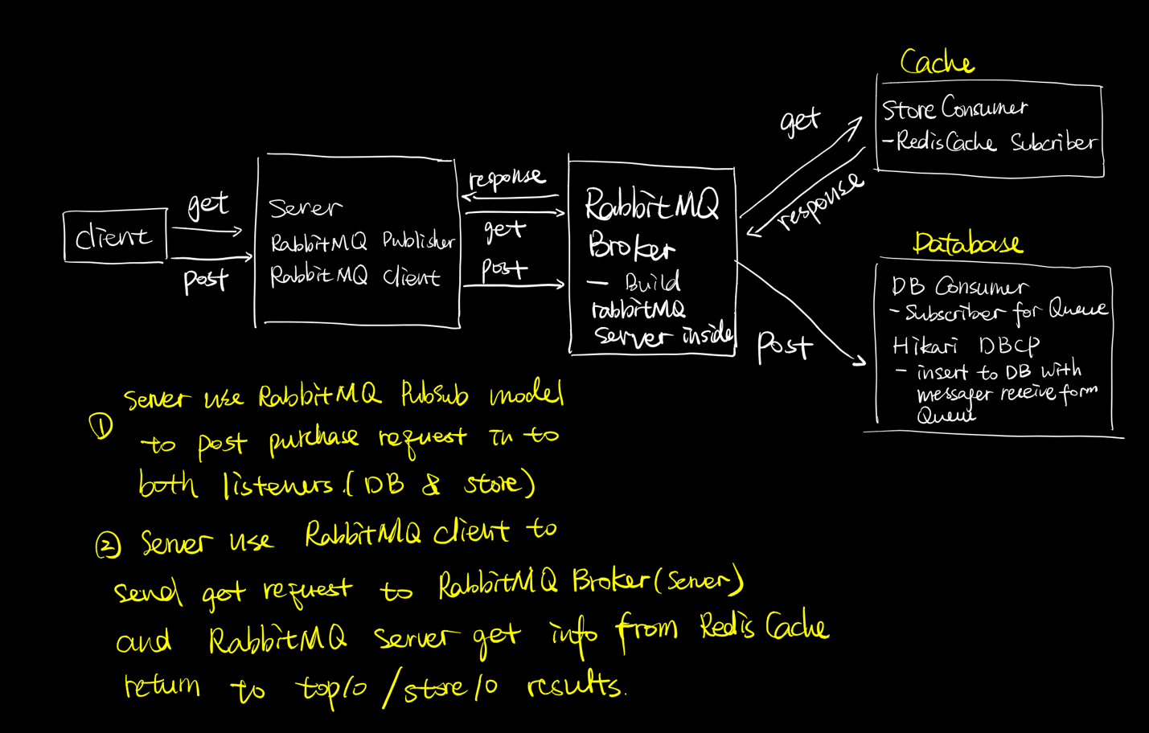

* *Total Three Packages @ “SuperMarketServer”:*

*MVC pattern used*

* model: (general utils for Server)
  + PurchaseRecord:
    - the data access object for each purchase request received, contains attributes match the database purchases table for each column
* Utils: (utils for RabbitMQ channel pools and RabbitMQClient, increased RabbitMQ speed)
  + ChannelFactory: utils for building RabbitMQ connection
  + ChannelPool: utils for building RabbitMQ connection
  + RabbitMQClient: used to publish the purchase request to RabbitMQ
* tools: (the purchase servlet)
  + PurchaseServlet: the server that handles purchase requests
    - have a RabbitMQ ChannelPool to build connections with RabbitMQ
    - valid http request if contains required URL path as header information
    - valid http request body is not empty while have a HTTP Post request
    - Get information from the URL path and request body to generate a PurchaseRecord to publish into RabbitMQ

(RabbitMQ Publisher: produce(PurchaseRecord)

* + - write captured information to response body, and send back
* *Total ONE class @ “RabbitMQBroker”:*
* RabbitMQServer:
  + use as microservice, get information from Redis cache in StoreConsumer
  + get tuple set from cache with provided key, and all its member elements and associated scores.
  + Top10Stores use a given ItemID to get, Top10Items use given StoreID to get
* *Total Two Class @ “StoreConsumer”:*
* PurchaseRecord:
  + the data access object for each purchase request received, contains attributes match the database purchases table for each column
* RedisConsumer:
  + used to subscribe messages from RabbitMQ publisher
  + save received message in Redis cache with storeID as key associated with all itemID as member and its scores, and another cache with ItemID as key associated with all storeID as member and its scores
* *Database Design:*
* One table names “Puchases” to store all purchase request as each row input
* Table contains:
* UUID as primary key, and avoid data duplication
* StoreID as Integer
* CustomerID as Integer
* Data as String -> with the given date send by client2 purchase URL
* CreateTime as Timestamp, takes the server system time while insert to DB
* PurchaseBody as Json that contains all purchase items information
* *Total Three Packages @ “DBConsumer”:*
* dal: (the DB connection)
  + DBCPDataSource:
    - Use HikariCP as the Database Connection Pool configuration
    - set a max pool size of 15
    - set max possible lifetime for connection in pool for 20 mins
  + PurchaseDao:
    - Setup and close Database Connection Pool (DBCP) connections
    - Insert data to purchase table with executing SQL queries
    - Enforce successful insertion, when insertion fail, keep inserting until successful, avoid failed insertion that give a failed http response back to client and cause a resend of duplicate purchase call
* model: (general utils for Server)
  + PurchaseRecord:
    - the data access object for each purchase request received, contains attributes match the database purchases table for each column
* Tools:
  + DBConsumer: The Database subscriber for Rabbitmq, get message from queue as PurchaseRecord, insert into DB use Hikari
* *Total Two Packages @ “SuperMarketClient”:*
* model: (general utils for both client2)
  + Record: the record object used to store all latency results for Client2
  + LogStderr: the error logger for write out system error to err.txt file
  + HttpMethod: Enum for POST and GET
  + CmdParser: set up required and optional command line input options to run client2
* part2: (package for client 2 to generate requested outputs)
  + Clinet2:
    - Main for execute all threads by calling SingleThread in package part2
    - Check if command line arguments are valid
    - Generate output results for part 2, print out to console
  + SingleThread:
    - the single runnable object represents as one thread to make purchase requests with remote server
    - when send purchase request failed, retry maximum 3 times to make purchase request send successfully
    - Use AtomicInteger to count the total successful/unsuccessful requests
    - Use CountDownLatch to initiate phase 2 and phase 3 threads
    - designed for Client 2 to capture start and end time of each request, in order to get latency time
    - use LogStderr to log errors into txt file
  + RecordWriter:
    - Runnable object used to generate Records object and write to csv file
    - Using BlockingQueue, and work as a Consumer, when consider each SingleThread are all producers of the queue
  + ReportGenerator:
    - Generate output results for part 2, print out to console
    - Read in all Records stored in CSV and get all Latency in to a list and sort list
    - Analysis all latency list, and get mean, median, max and p99 response time

Below are the output results for Client2 and analysis Charts:

* Results based on run free tier server \* 4 with load balancing, 4 CPU client, 8 CPU Ubuntu instance including RabbitMQBroker, StoreConsumer and DBConsumer and freetier RDS
* *With 256 Threads Single Server in A2:*

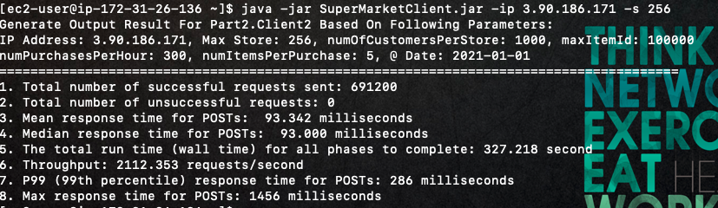

* *With 256 Threads Single Server Using RabbitMQ and Redis in A3:*

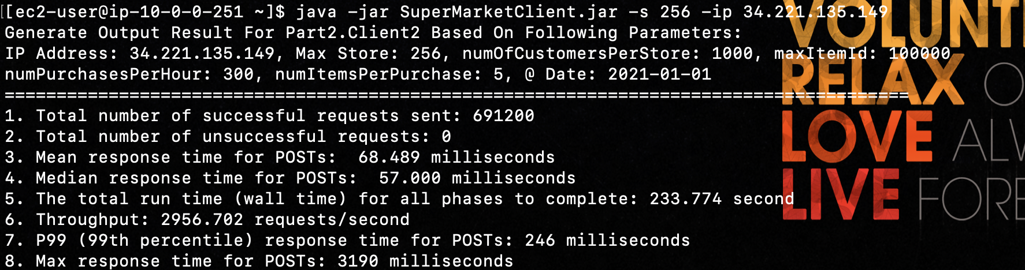

Single Server for A2 VS A3 did show higher throughput with using the RabbitMQ technology

* *With 256 Threads Load Balanced Server with Hikari in A2:*

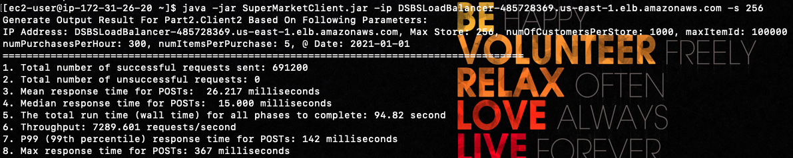

* *With 256 Threads Load Balanced Server Using Non-persistent RabbitMQ and Redis in A3:*

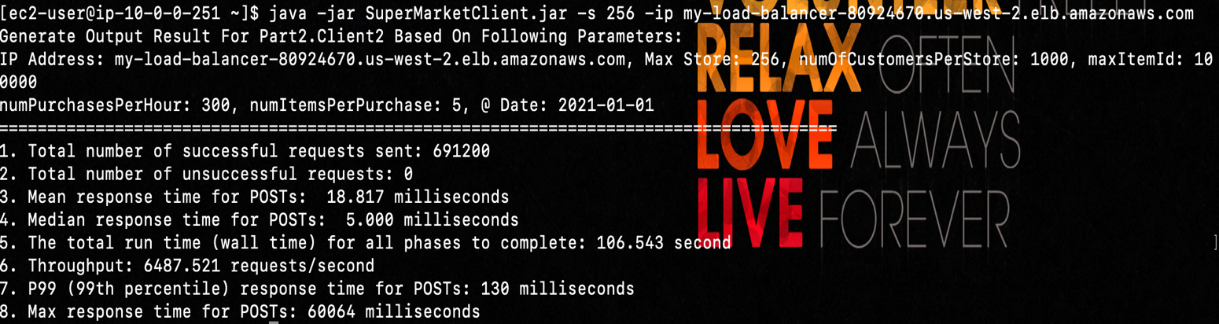

* *With 256 Threads Load Balanced Server Using Persistent RabbitMQ and Redis in A3:*

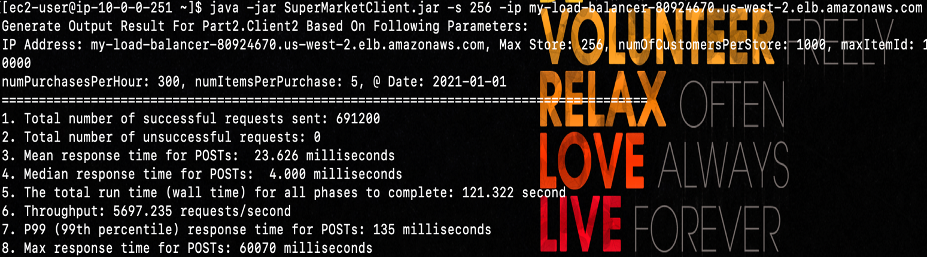

* *With 512 Threads Load Balanced Server in A2:*

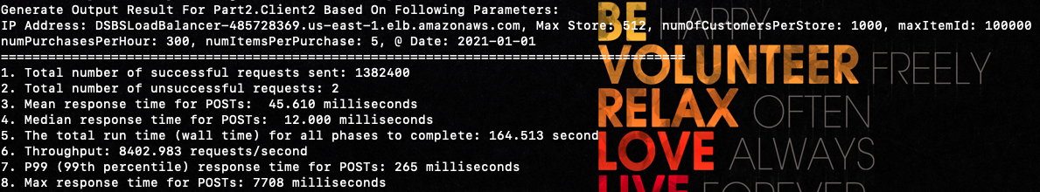

* *With 512 Threads Load Balanced Server Using RabbitMQ and Redis in A3:*

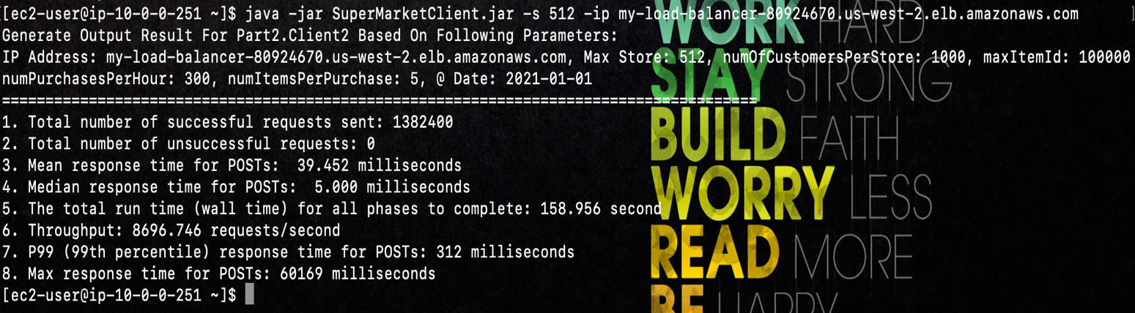

* *GET Top10 Results for ItemID 92521:*

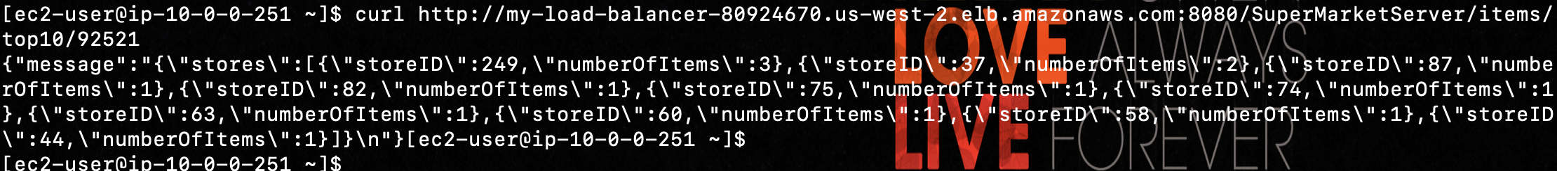

* *GET Store Results for StoreID200:*

*